# Interact with friends

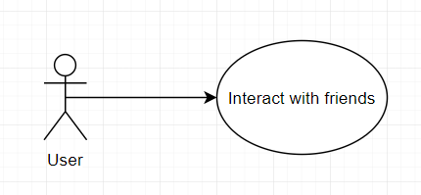

1.1 Characteristic Information

|  |  |
| --- | --- |
| Goal: | The user should be able to have contact with his/her friend/s |
| Precondition: | The user want to hang out with a friend with an application for a quick way to chat or to talk about something. |
| Postcondition: | The user |
| Involved User: | The user and a friend |
| Triggering Event: | The user want to talk or chat with a friend via an application. |

1.2 GUI to call the use case